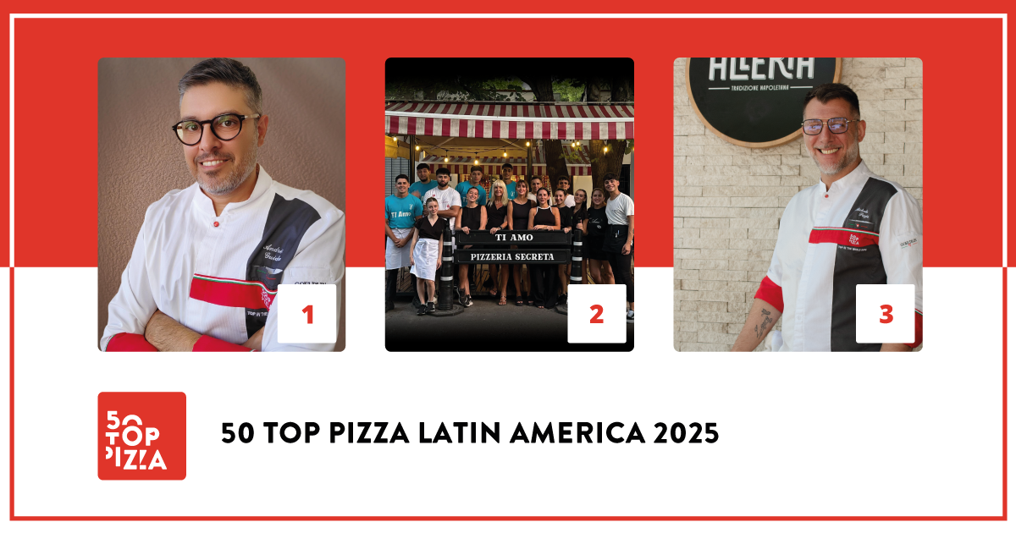

**50 TOP PIZZA LATIN AMERICA 2025:**

**LEGGERA PIZZA NAPOLETANA CONFIRMED AS THE BEST PIZZERIA IN LATIN AMERICA**

**Second place goes to Ti Amo in Buenos Aires, Argentina; third place goes to Allería in Providencia, Chile**

**Pizza Maker of the Year Yoselin Maria Tavares from Portarossa, in Pampatar, Venezuela; Pizza of the Year “Scampi” by Ferro e Farinha, in Rio de Janeiro, Brazil**

*April 11th, 2025* - **Leggera Pizza Napoletana** by **André Guidon** in São Paulo, Brazil, has been confirmed as the best pizzeria in Latin America for the year 2025. This is the result according to the most influential guide in the sector, **50 Top Pizza**, announced yesterday evening at the **Istituto Italiano di Cultura of Rio de Janeiro**, during the highly followed ceremony that was broadcast live on the network's social channels and presented by popular actor and showman Nicola Siri.

In second place we have **Ti Amo**, by Victoria and Carola Santoro, in Buenos Aires, Argentina; third place goes to **Allería** in Providencia, Chile.

In fourth place we have **Ferro e Farinha** in Rio de Janeiro, Brazil. For the fifth position we have a tie, both in the city of São Paulo, **QT Pizza Bar**, by Matheus Ramos, and **A Pizza da Mooca**, by Fellipe Zanuto; in sixth place we have pizzeria **Flama** in Miraflores, Peru; seventh place goes to **Unica Pizzeria**, São Paulo, Brazil; eighth place for **Portarossa**, Pampatar, Venezuela; in ninth place **La Clásica**, in San Salvador; in tenth place **L'Incanto**, Punta del Este, Uruguay; and in eleventh place we have **Veridiana**, São Paulo, Brazil.

The first **11 positions** in the **50 Top Pizza Latin America 2025** list - there is one more than last year - are automatically into the **100 World's Best Pizzerias** rankings. During the awards ceremony, the top 11 received the **Golden Ticket**, which is the pass that gives access to the **50 Top Pizza World 2025** ceremony, scheduled for **September 8th** in Naples at the **Teatro Mercadante**.

**The Special Awards of the evening**

The **Pizza Maker of the Year 2025 - Ferrarelle Award** goes to **Yoselin Maria Tavares** of **Portarossa**, Pampatar, Venezuela; the **Pizza of the Year 2025 - Latteria Sorrentina Award** goes to **“Scampi”** from the **Ferro e Farinha** pizzeria by Sei Shiroma, Rio de Janeiro, Brazil; the **New Entry of the Year 2025 - Solania Award** goes to **Pizzardi Artigianale** in Bogotá, Colombia; and the **Best Pasta Proposal 2025 - Pastificio Di Martino Award** goes to **Flama**, in Miraflores, Peru.

The **One to Watch 2025 - C-Trade Gourmet Award** goes to **Raffaella** in Las Condes, Chile; the **Best Fried Food 2025 - Il Fritturista - Oleificio Zucchi Award** goes to **Bento Pizzeria**, Rio de Janeiro, Brazil; the **Performance of the Year 2025 - Robo Award** goes to **La Clásica** in San Salvador, El Salvador; the **Best Dessert List 2025 - Latteria San Salvatore Award** goes to **L'Incanto,** Punta del Este, Uruguay. The **Best Beer Service 2025 - Peroni Nastro Azzurro Award** goes to **Paradiso,** Pedro Juan Caballero, Paraguay; the **Made in Italy 2025 - Salumi Coati Award** goes to **Unica Pizzeria** in São Paulo, Brazil; and, finally, the **Best Cocktail List 2025 - Sei Bellissimi Award** goes to **Veridiana** in São Paulo, Brazil.

The only **Green Oven 2025 - Goeldlin** award, recognition given to pizzerias that show attention to environmental sustainability, goes to **Seba's** in Uvita, Costa Rica.

This year, the most represented country in Latin America is **Brazil** with **25** pizzerias, followed by **Chile** with **6**, and **Argentina** with **5**. The most represented cities are **São Paulo** and **Rio de Janeiro** with **6** pizzerias, followed by **Buenos Aires** with **3**.

“*A pizza community, that of Latin America, that continues to grow in quality* – declare the curators of the guide **Barbara Guerra**, **Luciano Pignataro** and **Albert Sapere** –. *Brazil remains a point of reference for the South American Continent but there are also many other emerging realities in many of the different states here that are doing really well; from Chile to Argentina, from Uruguay to Peru. We would like to thank the Istituto Italiano di Cultura of Rio de Janeiro, for the warm welcome, and Bráz Pizzaria that hosted our party*”.

The next appointment with **50 Top Pizza** is set for **June 4th**, and it's going to be broadcast live from Madrid. There, we are going to discover which will be the **best pizzerias in Europe** (excluding Italy) for the year **2025**.

**Project Partners:**

**Pastificio Di Martino, Ferrarelle, Latteria Sorrentina, Oleificio Zucchi, Solania, Salumificio F.lli Coati, Sei Bellissimi, Robo 1938, Peroni Nastro Azzurro, Latteria San Salvatore, Goeldlin, Fedegroup, C-Trade Gourmet.**

**50 Top Pizza Latin America 2025 – Complete Ranking**

1 Leggera Pizza Napoletana - São Paulo, Brazil

2 Ti Amo - Adrogué, Argentina

3 Allería - Providencia, Chile

4 Ferro e Farinha - Rio de Janeiro, Brazil

5 A Pizza da Mooca - São Paulo, Brazil

5 QT Pizza Bar - São Paulo, Brazil

6 Flama - Miraflores, Peru

7 Unica Pizzeria - São Paulo, Brazil

8 Portarossa - Pampatar, Venezuela

9 La Clásica - San Salvador, El Salvador

10 L'Incanto - Punta del Este, Uruguay

11 Veridiana - São Paulo, Brazil

12 Ardente - Mexico City, Mexico

13 Atte. Pizzeria Napoletana - Buenos Aires, Argentina

14 Imilla Alzada - La Paz, Bolivia

15 GRAZIE - Maceió, Brazil

16 Capricciosa - Rio de Janeiro, Brazil

17 Chichilo's - Santa Fe, Argentina

18 Baco Pizzaria - Brasilia, Brazil

19 Siamo nel Forno - Buenos Aires, Argentina

20 400 Pizzería - Providencia, Chile

21 Coltivi - Rio de Janeiro, Brazil

22 Pizzardi Artigianale - Bogotá, Colombia

23 Grazie Napoli - Santo André, Brazil

24 Luigia - Foz do Iguaçu, Brazil

25 Nuvola - Buenos Aires, Argentina

26 Quintal 333 - Governador Valadares, Brazil

27 Davvero Pizzeria - Ñuñoa, Chile

28 Di Bari Pizza - São Paulo, Brazil

29 Paradiso - Pedro Juan Caballero, Paraguay

30 Capri - Lo Barnechea, Chile

31 ST Giovanni’s - Las Condes, Chile

32 Otto e Mezzo Pizza Verace - Bento Gonçalves, Brazil

33 Frasca - Carlos Barbosa, Brazil

34 Il Caminetto - Santo Domingo, Dominican Republic

35 Vinny's - Brasilia, Brazil

36 Bento Pizzeria - Rio de Janeiro, Brazil

37 Pizza di Casabona - Santos, Brazil

38 L'Aperó - Guatemala City, Guatemala

39 Raffaella - Las Condes, Chile

40 La Nonna - Aguascalientes, Mexico

41 Bambina - Caguas, Puerto Rico

42 Ella Pizzaria - Rio de Janeiro, Brazil

43 Piccola Fattoria - Rio de Janeiro, Brazil

44 Dopodomani Pizza Gourmand - Chacao, Venezuela

45 Wilma’s Pizza - Ourinhos, Brazil

46 Seba's - Uvita, Costa Rica

47 Grosso - Asunción, Paraguay

48 LE MANI Pizza Napoletana - Passo Fundo, Brazil

49 Vallino Pizzeria Napoletana - Domingos Martins, Brazil

50 CIAO - Porto Alegre, Brazil

50 La Bella Pizza - Cali, Colombia

**50 Top Pizza Latin America 2025 – Special Awards**

**• One to Watch 2025 - C-Trade Gourmet Award**

Raffaella - Las Condes, Chile

**• Pizza Maker of the Year 2025 - Ferrarelle Award**

Yoselin Maria Tavares at Portarossa - Pampatar, Venezuela

**• New Entry of the Year 2025 - Solania Award**

Pizzardi Artigianale - Bogotá, Colombia

**• Best Fried Food 2025 - Il Fritturista - Oleificio Zucchi Award**

Bento Pizzeria - Rio de Janeiro, Brazil

**• Pizza of the Year 2025 - Latteria Sorrentina Award**

Scampi by Ferro e Farinha - Rio de Janeiro, Brazil

**• Performance of the Year 2025 - Robo Award**

La Clásica - San Salvador, El Salvador

**• Best Pasta Proposal 2025 - Pastificio Di Martino Award**

Flama - Miraflores, Peru

**• Best Dessert List 2025 - Latteria San Salvatore Award**

L'Incanto - Punta del Este, Uruguay

**• Best Beer Service 2025 - Peroni Nastro Azzurro Award**

Paradiso - Pedro Juan Caballero, Paraguay

**• Made in Italy 2025 - Salumi Coati Award**

Unica Pizzeria - São Paulo, Brazil

**• Best Cocktail List 2025 - Sei Bellissimi Award**

Veridiana - São Paulo, Brazil

**50 Top Pizza Latin America – Green Oven 2025 - Goeldlin**

• **Seba's** - Uvita, Costa Rica

**50 Top Pizza Latin America - Top in Country 2025**

**Top Pizzeria in Brazil 2025** – Leggera Pizza Napoletana - São Paulo, Brazil

**Top Pizzeria in Argentina 2025** – Ti Amo - Adrogué, Argentina

**Top Pizzeria in Chile 2025** – Allería - Providencia, Chile

**Top Pizzeria in Peru 2025** – Flama - Miraflores, Peru

**Top Pizzeria in Venezuela 2025** – Portarossa - Pampatar, Venezuela

**Top Pizzeria in El Salvador 2025** – La Clásica - San Salvador, El Salvador

**Top Pizzeria in Uruguay 2025** – L'Incanto - Punta del Este, Uruguay

**Top Pizzeria in Mexico 2025** – Ardente - Mexico City, Mexico

**Top Pizzeria in Bolivia 2025** – Imilla Alzada - La Paz, Bolivia

**Top Pizzeria in Colombia 2025** – Pizzardi Artigianale - Bogotá, Colombia

**Top Pizzeria in Paraguay 2025** – Paradiso - Pedro Juan Caballero, Paraguay

**Top Pizzeria in the Dominican Republic 2025** – Il Caminetto - Santo Domingo, Dominican Republic

**Top Pizzeria in Guatemala 2025** – L'Aperó - Guatemala City, Guatemala

**Top Pizzeria in Puerto Rico 2025** – Bambina - Caguas, Puerto Rico

**Top Pizzeria in Costa Rica 2025** – Seba's - Uvita, Costa Rica

**Next Events for 50 Top Pizza 2025**

**• 50 Top Pizza Europa 2025** – June 4th, Madrid

**• 50 Top Pizza USA 2025** – July 1st, New York

**• 50 Top Pizza Italia 2025** – July 15th, Milan

**• 50 Top Pizza World 2025** – September 8th, Naples

**• 50 Top World Artisan Pizza Chains 2025** – November 27th, London

*As with all of the rankings under the 50 Top brand, 50 Top Pizza Latin America 2025 is also the result of the annual labor carried out by the inspectors who collaborate with our project and who have examined an enormous number of pizzerias located throughout the entire area. They always respect our policy of anonymous visits and inspections. The criteria for evaluation include scales regarding the overall care given to the well-being of the customer, beginning of course with the quality of the products.*