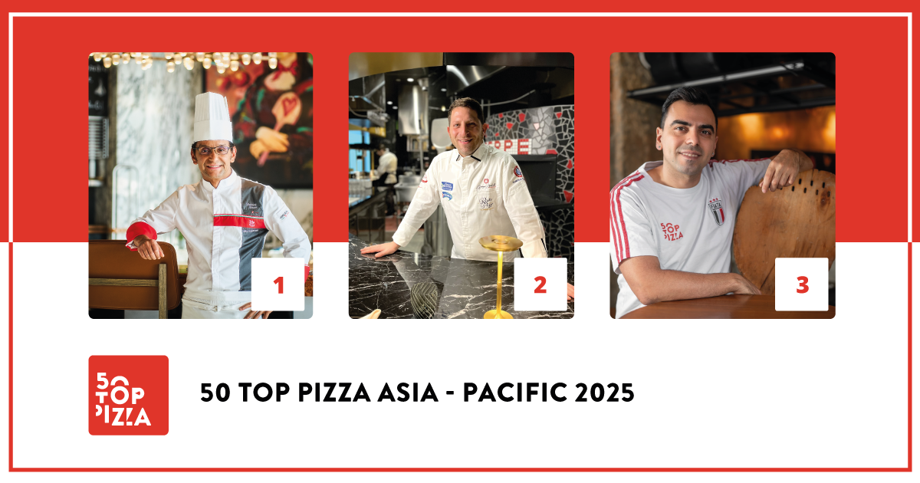

**50 TOP PIZZA ASIA - PACIFIC 2025:**

**THE PIZZA BAR ON 38TH IN TOKYO IS THE BEST PIZZERIA IN THE ASIA-PACIFIC AREA FOR THE YEAR 2025**

**Tribute to Margarita Forés during the ceremony**

**Second place for RistoPizza by Napoli sta ca, in Tokyo; third place for Fiata by Salvatore Fiata, in Hong Kong**

**Pizza Maker of the Year Susanna Di Cosimo at pizzeria da Susy, India; Pizza of the Year *Norma not Normal* by Massilia, in Bangkok**

*Tokyo, March 10th, 2025* - During the awards ceremony held at the **Istituto Italiano di Cultura** in Tokyo, **50 Top Pizza**, the most influential guide in the world of pizza, announced the ranking of the **50 Best Pizzerias in the Asia-Pacific area for the year 2025**.

**The Pizza Bar on 38th** was confirmed to be the best pizzeria for **50 Top Pizza Asia - Pacific 2025**. It is the smallest pizzeria in the world, with its 8 seats, led by Daniele Cason, executive chef of the Mandarin Oriental in Tokyo. Second place goes to **RistoPizza by Napoli sta ca** by Giuseppe Errichiello, in the Azabudai Hills Store, Tokyo. Closing the podium is **Fiata by Salvatore Fiata** in Hong Kong.

Fourth place was given to **Massilia** in Bangkok, led by Luca Appino and Michele Fernando. Next up we have a tie for fifth place with **Crosta**, in Manila, by Ingga S. Cabangon Chua and Thomas Woudwyk, led by Yuichi Ito, and **SHOP225** in Melbourne, by Lorenzo Tron. Coming in sixth is **da Susy** in Gurugram, India, by Susanna Di Cosimo. Another tie is for the seventh place, with **a mano**, in Manila, by Amado Forés, and **Dante's Pizzeria by Enis Baçova** in Auckland, New Zealand. Eighth place goes to **Bottega** in Beijing, by the Salvo brothers. In ninth place we have **Spacca Napoli** in Seoul, South Korea, by Giulio Lee. Closing the top ten is **Pizzeria Braceria CESARI!!** by Pasquale Makishima, in Nagoya.

Next up are **Margherí** in Ho Chi Minh City, Vietnam, **48h Pizza e Gnocchi Bar** in Melbourne, and, in thirteenth place, **ANTO** in Singapore.

The **top 13** in the **50 Top Pizza Asia - Pacific 2025** ranking are automatically part of the **100 Best Pizzerias in the World**, and they will attend the **Teatro Mercadante** event in Naples on **September 8th**.

The very intense and highly followed awards ceremony was broadcast live on the network's social media channels. It was presented by **Imma Romano** and welcomed by His Excellency **Gianluigi Benedetti**, Ambassador of Italy in Japan.

**The Special Awards of the evening  
Susanna Di Cosimo** of pizzeria **da Susy** in Gurugram, India, wins the **Pizza Maker of the Year 2025 - Ferrarelle Award**; **Norma not Normal** by **Massilia** in Bangkok wins the **Pizza of the Year 2025 - Latteria Sorrentina Award**; **Margherí** in Ho Chi Minh City, Vietnam, wins the **Performance of the Year 2025 - Robo Award**; the **New Entry of the Year 2025 - Solania Award** goes to **NeoPolitan** in Haifa, Israel; the **One to Watch 2025 - Monte Bussan Award** goes to **ANTO** in Singapore; the **Made in Italy 2025 - Salumi Coati Award** goes to **Pizzeria** **Marione** in Seoul; the **Best Fried Food 2025 - Il Fritturista - Oleificio Zucchi Award** goes to **Fortuna** in Singapore.

The **Best Pasta Proposal 2025 - Pastificio Di Martino Award** goes to **RistoPizza by Napoli sta ca**, in Tokyo; **L’OLIVA** in Bangkok, Thailand, wins the **Best Dessert List 2025 - Latteria San Salvatore Award**; the **Best Beer Service 2025 - Peroni Nastro Azzurro Award** goes to **gigi’s**, in Sydney; the **Best Cocktail List 2025 - Sei Bellissimi Award** goes to **Fiata by Salvatore Fiata**, in Hong Kong; and the **Best Customer Satisfaction 2025 - Grassl Glass Award**, lastly, goes to **SHOP225**, in Melbourne.

**Australia** is the most represented nation with **10** pizzerias, followed by **Japan** with **9** and **China** with **6**. As for the cities, the most represented is **Tokyo** with **6** pizzerias, followed by **Melbourne** and **Hong Kong** with **4** pizzerias each.

“*The pizza movement is also in great upheaval in this part of the world -* stated the three curators of the guide: **Barbara Guerra**, **Luciano Pignataro** and **Albert Sapere** *- with Australia that in recent years has made significant steps forward in terms of quality and with Singapore and Hong Kong as emerging destinations. The entire Asian continent is experiencing a period of growth in this sector and this fact presents an opportunity for Italian gastronomic culture. It was our wish to dedicate the Asia - Pacific 2025 ceremony to Margarita Forés, who passed away last February 11th. She was a true icon of Italian quality food abroad, who in recent years had made a significant contribution to the world of pizza*”.

The next appointment with **50 Top Pizza** is set for **April 10th** which will be broadcast live from Rio de Janeiro, to discover the best pizzerias in Latin America for the year 2025.

**Project Partners:**

**Pastificio Di Martino, Ferrarelle, Latteria Sorrentina, Oleificio Zucchi, Solania, Salumificio F.lli Coati, Sei Bellissimi, Robo 1938, Peroni Nastro Azzurro, Latteria San Salvatore, Goeldlin, Fedegroup, Monte Bussan, Grassl Glass.**

**50 Top Pizza Asia - Pacific 2025 – Complete Ranking**

1 The Pizza Bar on 38th - Tokyo, Japan

2 RistoPizza by Napoli sta ca - Tokyo, Japan

3 Fiata by Salvatore Fiata - Hong Kong, China

4 Massilia - Bangkok, Thailand

5 Crosta - Makati, Philippines

5 SHOP225 - Melbourne, Australia

6 da Susy - Gurugram, India

7 a mano - Makati, Philippines

7 Dante's Pizzeria by Enis Baçova - Auckland, New Zealand

8 Bottega - Beijing, China

9 Spacca Napoli - Seoul, South Korea

10 Pizzeria Braceria CESARI!! - Nagoya, Japan

11 Margherí - Ho Chi Minh City, Vietnam

12 48h Pizza e Gnocchi Bar - Melbourne, Australia

13 ANTO - Singapore, Singapore

14 Il Caffè - Dubai, United Arab Emirates

15 Pizzeria Marione - Seoul, South Korea

16 La Tripletta - Tokyo, Japan

17 Al Taglio - Sydney, Australia

18 Pizza Strada - Tokyo, Japan

19 Pizzeria da Tigre - Osaka, Japan

20 Pizzeria Mazzie - Bangkok, Thailand

21 L’OLIVA - Bangkok, Thailand

22 L'INSIEME - Tokyo, Japan

23 BACI - Hong Kong, China

24 Queen Margherita of Savoy - Sydney, Australia

25 NeoPolitan - Haifa, Israel

26 Lil Franky Pizzeria - Sydney, Australia

27 Five Olives - Phuket, Thailand

28 Fortuna - Singapore, Singapore

29 gigi’s - Sydney, Australia

30 MASSIMOTTAVIO - Tokyo, Japan

31 Il Caminetto - Melbourne, Australia

32 Little Napoli - Hong Kong, China

33 +39 Pizzeria - Melbourne, Australia

34 Andrea Style - Taipei City, Taiwan

35 Pizzeria da CIRO - Kyoto, Japan

36 Marni - Phuket, Thailand

37 Piedra - Jerusalem, Israel

38 MAESTRO Sourdough Pizza - Perth, Australia

39 Pizzeria Cavalese - Jakarta, Indonesia

40 Beintema's - Bandung, Indonesia

41 Leo’s - New Delhi, India

42 Wildflour Italian - Taguig, Philippines

43 SOLO Pizza Napulitana - Kuwait City, Kuwait

44 Vesu Pizza Bar - Hong Kong, China

45 Est Ovest - Adelaide, Australia

46 Banco Pizza - Taipei City, Taiwan

47 90 Seconds - Shenzhen, China

48 Minante Pizzeria - Cebu City, Philippines

49 Napoli Contemporanea - Auckland, New Zealand

50 Proof Pizza - Kuala Lumpur, Malaysia

**50 Top Pizza Asia - Pacific 2025 – Special Awards**

**• One to Watch 2025 - Monte Bussan Award**

ANTO - Singapore, Singapore

**• Pizza Maker of the Year 2025 - Ferrarelle Award**

Susy Di Cosimo at da Susy - Gurugram, India

**• New Entry of the Year 2025 - Solania Award**

NeoPolitan - Haifa, Israel

**• Best Fried Food 2025 - Il Fritturista - Oleificio Zucchi Award**

Fortuna - Singapore, Singapore

**• Pizza of the Year 2025 - Latteria Sorrentina Award**

Norma not Normal by Massilia - Bangkok, Thailand

**• Performance of the Year 2025 - Robo Award**

Margherí - Ho Chi Minh City, Vietnam

**• Best Pasta Proposal 2025 - Pastificio Di Martino Award**

RistoPizza by Napoli sta ca - Tokyo, Japan

**• Best Dessert List 2025 - Latteria San Salvatore Award**

L’OLIVA - Bangkok, Thailand

**• Best Beer Service 2025 - Peroni Nastro Azzurro Award**

gigi’s - Sydney, Australia

**• Made in Italy 2025 - Salumi Coati Award**

Pizzeria Marione - Seoul, South Korea

**• Best Cocktail List 2025 - Sei Bellissimi Award**

Fiata by Salvatore Fiata - Hong Kong, China

• **Best Customer Satisfaction 2025 - Grassl Glass Award**

SHOP225 - Melbourne, Australia

**50 Top Pizza Asia - Pacific - Top in Country 2025**

**Top Pizzeria in Japan 2025** - The Pizza Bar on 38th - Tokyo, Japan

**Top Pizzeria in Hong Kong 2025** - Fiata by Salvatore Fiata - Hong Kong, China

**Top Pizzeria in Thailand 2025** - Massilia - Bangkok, Thailand

**Top Pizzeria in the Philippines 2025** - Crosta - Makati, Philippines

**Top Pizzeria in Australia 2025** - SHOP225 - Melbourne, Australia

**Top Pizzeria in India 2025** - da Susy - Gurugram, India

**Top Pizzeria in New Zealand 2025** - Dante's Pizzeria by Enis Baçova - Auckland, New Zealand

**Top Pizzeria in Mainland China 2025** - Bottega - Beijing, China

**Top Pizzeria in South Korea 2025** - Spacca Napoli - Seoul, South Korea

**Top Pizzeria in Vietnam 2025** - Margherí - Ho Chi Minh City, Vietnam

**Top Pizzeria in Singapore 2025** - ANTO - Singapore, Singapore

**Top Pizzeria in the United Arab Emirates 2025** - Il Caffè - Dubai, United Arab Emirates

**Top Pizzeria in Israel 2025** - NeoPolitan - Haifa, Israel

**Top Pizzeria in Taiwan 2025** - Andrea Style - Taipei City, Taiwan

**Top Pizzeria in Indonesia 2025** - Pizzeria Cavalese - Jakarta, Indonesia

**Top Pizzeria in Kuwait 2025** - SOLO Pizza Napulitana - Kuwait City, Kuwait

**Top Pizzeria in Malaysia 2025** - Proof Pizza - Kuala Lumpur, Malaysia

**Next Events for 50 Top Pizza 2025**

**• 50 Top Pizza Latin America 2025** – April 10th, Rio de Janeiro

**• 50 Top Pizza Europa 2025** – June 4th, Madrid

**• 50 Top Pizza USA 2025** – July 1st, New York

**• 50 Top Pizza Italia 2025** – July 15th, Milan

**• 50 Top Pizza World 2025** – September 8th, Naples

**• 50 Top World Artisan Pizza Chains 2025** – November 27th, London

*As with all of the rankings under the 50 Top brand, 50 Top Pizza Asia - Pacific 2025 is also the result of the annual work of our inspectors that collaborate with this project and who have examined an enormous number of pizzerias dispersed throughout the entire Continent. Visits are always carried out anonymously, as per guide policy. The criteria for assessment include the attention given, on the whole, to customer satisfaction, beginning of course with the quality of the products.*