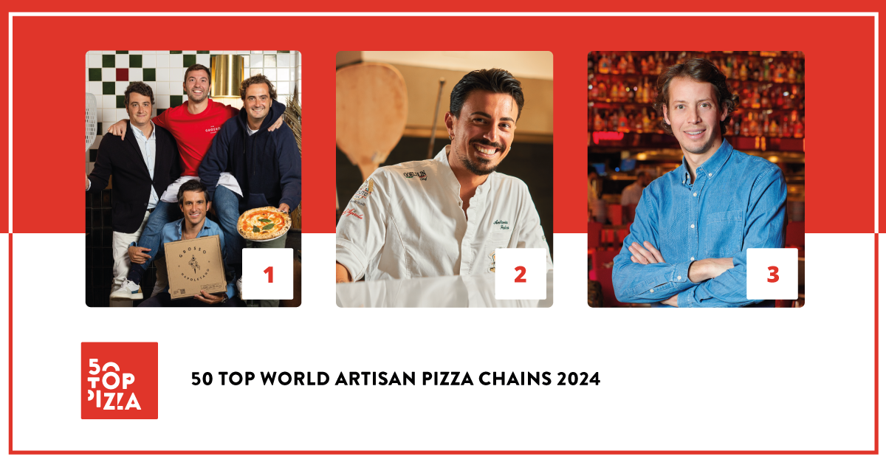

**50 TOP WORLD ARTISAN PIZZA CHAINS 2024:**

**GROSSO NAPOLETANO IS THE BEST ARTISAN PIZZERIA CHAIN IN THE WORLD. IN SECOND PLACE IS DA MICHELE, ON THE THIRD STEP OF THE PODIUM IS BIG MAMMA GROUP.**

*London, 28th November 2024* – The ranking of the **50 Top World Artisan Pizza Chains** is prepared by **50 Top Pizza**, the most important worldwide guide in the sector. 50 Top Pizza was created and is curated by **Barbara Guerra**, **Albert Sapere** and **Luciano Pignataro**. The **2024 results** for the Best Artisan Pizza Chains in the World were presented yesterday evening during the **World Pizza Summit 2024** held inside the **European Pizza Show** in London.

**Grosso Napoletano** was reconfirmed, for the second consecutive year, as the best artisan pizzeria chain in the world: founded in 2017, their mission was to bring the Neapolitan pizza style to Spain, first to Madrid and then to Barcelona, Seville, Saragoza and in other centers throughout the Iberian Peninsula. Second place went to **Da Michele**, which has been in operation for 150 years in the heart of Forcella in Naples, and today it boasts more than 60 locations spread over several continents where it is possible to taste their celebrated “*wagon wheel*” (*a ruota di carro*) pizza.

In third position is **Big Mamma Group**, an organization born out of two French entrepreneur’s love for Italy, Victor Lugger and Tigrane Seydoux. Today it boasts numerous locations in France, Spain, England and Germany.

In fourth position is **Bráz Pizzaria**, a Brazilian enterprise famous for its large and crunchy pizza baked in a wood-fired oven. Fifth position went to **Luigia**, which has outlets in Switzerland and Dubai. Their pizzas are served with a selection of the highest quality Italian products. In sixth place is **Berberè** owned by the Aloe brothers. They began with a single pizzeria in Castel Maggiore in the province of Bologna and now they are open in London after having established approximately ten locations in Rome, Florence, Turin and Milan. Seventh position went to **Pizza Pilgrims** a landmark for Neapolitan pizza in the United Kingdom. In Eighth position is **400 Gradi**, which has locations in both Melbourne and Dallas. It is owned by Johnny Di Francesco, a bonafide ambassador of Neapolitan pizza in the new continent. In ninth position is **Eataly,** which has locations in Italy and the rest of the world; it is a well-recognized brand among Made in Italy enthusiasts. Tenth place went to **Pizzium**, which has recently surpassed 50 locations open in Italy, all under direct management.

The highly anticipated **special awards** recognized the executive pizza maker at **Da Michele, Antonio Falco,** as the **Pizza Maker of the Year 2024 - Ferrarelle Award**; the **Pizza of the Year 2024 - Latteria Sorrentina Award** went to **Salsiccia e Friarielli** at **Pizza Pilgrims**; the **Best Pasta Proposal 2024 - Pastificio Di Martino Award** was awarded to **Eataly**; the **Best Marketing 2024 - Mammafiore Award** went to **Vincenzo Capuano**; the **New Entry of the Year 2024** - **Solania Award** went to **La Braciera**; the **Performance of the Year 2024 - Robo Award** went to **1900 Pizzeria**; the **One to Watch 2024 - Casa Julia Award** was given to **Stellina Pizzeria**; the **Best Service 2024 - Fedegroup Award** was awarded to **Luigia**; the **Best Fried Food 2024** **- Il Fritturista - Oleificio Zucchi Award** was given to **Berberè**; the **Best Beer Service 2024 - Peroni Nastro Azzurro Award** went to **Doppio Zero**; the **Best Dessert List 2024 - Cremoso - La Dispensa Award** was given to **Can Pizza**; the **Best Wine List 2024 - La Gioiosa Award** went to **Big Mamma Group**. Finally, the **Green Oven 2024 – Goeldlin** award, which recognizes establishments that make environmental sustainability a priority, was conferred upon **Garden Pizza**.

The “Excellent” category is also a part of the current edition. These are notable artisan pizzeria chains which, together with the chains present in the top 50 ranking, complete the guide for a total of 81 brands.

“*We are incredibly proud of the work done by the chains present in the 50 Top World Artisan Pizza Chains 2024 guide this year*,” declare the three curators, **Barbara Guerra**, **Luciano Pignataro** and **Albert Sapere**, “*The total number of chains that has surpassed the quality standards of our inspectors is 81. Together they make up slightly less than 2000 points of sale with approximately 30,000 direct employees and a total annual revenue of about 3 billion dollars. It is a sector that is under continual expansion without any downturns and it is a testament to the fact that pizza is the world’s most consumed food product.”*

**Project Partners:**

**Pastificio Di Martino, Ferrarelle, Latteria Sorrentina, Oleificio Zucchi, Solania, Robo 1938, Peroni Nastro Azzurro, Cremoso - La Dispensa, Goeldlin, Fedegroup, Mammafiore, Casa Julia, La Gioiosa.**

**Complete Ranking for 50 Top World Artisan Pizza Chains 2024**

1 Grosso Napoletano

2 Da Michele

3 Big Mamma Group

4 Bráz Pizzaria

5 Luigia

6 Berberè

7 Pizza Pilgrims

8 400 Gradi

9 Eataly

10 Pizzium

11 Errico Porzio

12 Vincenzo Capuano

13 Gruppo Peppe

14 1900 Pizzeria

15 Sorbillo

16 Can Pizza

17 iQuintili

18 Paulie Gee's

19 Pizzana

20 Starita

21 Peppina

22 Doppio Zero

23 FRESCO

24 Alice Pizza

25 Fradiavolo

26 Fratelli La Bufala

27 Rudy's

28 Riva

29 Rossopomodoro

30 Menchetti

31 Via Tribunali

32 Da Zero

33 Zia Lucia

34 Garden Pizza

35 La Braciera

36 OLIO welovepizzanapoletana

37 Napulé

38 Vasinikò

39 Villa Paradiso

40 Stellina Pizzeria

41 Lievità

42 Gruppomimo

43 No. 900

44 CIBO

45 Pummarola

46 Crocca

47 mammamia!

48 Da Nanni

49 Motorino

50 Cinquecento

50 Tutta Bella

**50 Top World Artisan Pizza Chains 2024 - Special Awards**

**• Pizza Maker of the Year 2024 - Ferrarelle Award**

Antonio Falco - Da Michele

• **Best Pasta Proposal 2024 - Pastificio Di Martino Award**

Eataly

• **Best Marketing 2024 - Mammafiore Award**

Vincenzo Capuano

• **Best Service 2024 - Fedegroup Award**

Luigia

• **New Entry of the Year 2024 - Solania Award**

La Braciera

• **Pizza of the Year 2024 - Latteria Sorrentina Award**

Salsiccia e Friarielli - Pizza Pilgrims

• **Performance of the Year 2024 - Robo Award**

1900 Pizzeria

• **Best Wine List 2024 - La Gioiosa Award**

Big Mamma Group

• **Best Fried Food 2024 - Il Fritturista - Oleificio Zucchi Award**

Berberè

• **Best Beer Service 2024 - Peroni Nastro Azzurro Award**

Doppio Zero

• **One to Watch 2024 - Casa Julia Award**

Stellina Pizzeria

• **Best Dessert List 2024 - Cremoso - La Dispensa Award**

Can Pizza

**50 Top World Artisan Pizza Chains - Green Oven 2024 - Goeldlin**

• Garden Pizza

**50 Top World Artisan Pizza Chains 2024 – Excellent Pizza Chains**

<https://www.50toppizza.it/excellent-pizza-chains-2024/>

*As with all of the rankings under the 50 Top brand, 50 Top World Artisan Pizza Chains 2024 comes about thanks to the commitment our inspectors who collaborate annually with this project and who have examined an enormous number of pizzerias located throughout the entire world. The guide’s policy of complete anonymity during inspections is always upheld. The criteria for assessment include factors related to customer well-being on the whole, which obviously begins with the quality of the products. In the specific case of the artisan chains, they are categorized as brands with multiple locations or those with the same master pizza maker even if only as the face of the brand.*