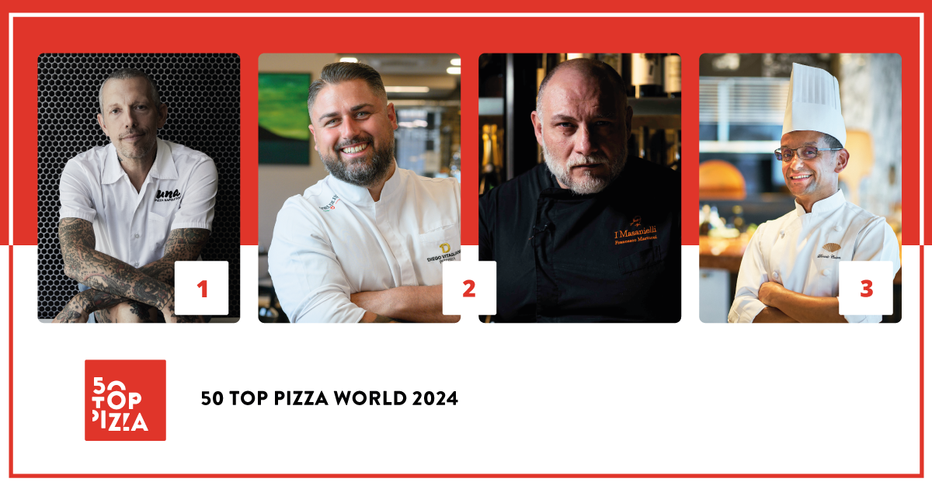

**50 TOP PIZZA WORLD 2024:**

**UNA PIZZA NAPOLETANA BY ANTHONY MANGIERI IN NEW YORK HAS BEEN NAMED THE BEST PIZZERIA IN THE WORLD FOR 2024**

**Tied for second place are Diego Vitagliano Pizzeria in Naples, and I Masanielli by Francesco Martucci in Caserta; completing the podium is The Pizza Bar on 38th in Tokyo.**

**Giorgia Caporuscio from Don Antonio in New York, has captured the special recognition Empower Women - Fedegroup Award for being a source of inspiration to female pizza makers around the World.**

**The Pizza Maker of the Year 2024 - Ferrarelle Award has gone to Matheus Ramos from QT Pizza Bar in São Paulo, Brazil; the Pizza of the Year 2024 - Latteria Sorrentina Award has gone to *Mission Impossible* at Tony's Pizza Napoletana in San Francisco; the Best Pasta Proposal 2024 - Pastificio Di Martino Award has gone to the pizzeria a mano in Manila, in the Philippines.**

*Naples, September 11th 2024* - **Una Pizza Napoletana** by **Anthony Mangieri** in New York has been named the Best Pizzeria in the world for 2024 by **50 Top Pizza**, the most important and heavily followed guide in the world. It is curated by **Barbara Guerra**, **Luciano Pignataro** and **Albert Sapere**. The verdict was announced at the **Teatro Mercadante** in Naples during the awards ceremony presented by **Verónica Zumalacárregui**, a Spanish journalist and influencer.

Second place ended in a tie between **Diego Vitagliano Pizzeria** in Naples, and **I Masanielli by Francesco Martucci** in Caserta, both of whom had captured first place for 50 Top Pizza Italia 2024; on the third step of the podium is **The Pizza Bar on 38th**, in Tokyo, managed by **Daniele Cason**, and which was number one for 50 Top Pizza Asia - Pacific 2024; fourth position went to **Confine** in Milan, by **Francesco Capece** and **Mario Ventura**; in fifth place is **Napoli on the Road** in London by **Michele Pascarella**.

Following is **Tony's Pizza Napoletana** in San Francisco, by **Tony Gemignani**; then **I Tigli** in San Bonifacio, by **Simone Padoan**; **Sartoria Panatieri** in Barcelona, by **Rafa Panatieri** and **Jorge Sastre**, and **50 Kalò** in Naples, by **Ciro Salvo**; closing the top ten is **Seu Pizza Illuminati**in Rome, by **Pier Daniele Seu**.

**The following are the special awards for 50 Top Pizza World 2024**:

The **Empower Women - Fedegroup Award** has gone to **Giorgia Caporuscio** from **Don Antonio** in New York, for the following reason: “*For having inspired female pizza makers all over the world, because making pizza has never been culturally considered to be the work of women; the fact that it has always been this way does not mean that it is right or that it should always be this way. Change does not happen on its own”.*

The **Pizza Maker of the Year 2024 - Ferrarelle Award** has gone to **Matheus Ramos** from **QT Pizza Bar** in São Paulo, Brazil; the **Pizza of the Year 2024 - Latteria Sorrentina Award** has gone to **Mission Impossible** at **Tony's Pizza Napoletana**, in San Francisco; the **Best Pasta Proposal 2024 - Pastificio Di Martino Award** has gone to the **a mano** pizzeria in Manila, in the Philippines, managed by **Amado Forés**; the **One to Watch 2024 - Orlando Foods Award** has gone to **Imilla Alzada** from La Paz, Bolivia; the **New Entry of the Year 2024 - Solania Award** has gone to **Stile Napoletano** by **Giacomo Guido**, in Chester, England; the **Best Dessert List 2024 - Cremoso - La Dispensa Award** has gone to **Allería** in Providencia, Chile; the **Performance of the Year 2024 - Robo Award** has gone to **Robert's** in Chicago; the **Best Fried Food 2024 - Il Fritturista - Oleificio Zucchi Award** has gone to **Clementina** by **Luca Pezzetta** in Fiumicino; the **Best Beer Service 2024 - Peroni Nastro Azzurro Award** has gone to **Apogeo** by **Massimo Giovannini**, in Pietrasanta; the **Made in Italy 2024 - Mammafiore Award** has gone to **Leggera Pizza Napoletana** by **André Guidon** in São Paulo, Brazil.

A further recognition **Green Oven 2024 - Goeldlin** which rewards careful attention to environmental sustainability has been given to **Cambia-Menti di Ciccio Vitiello**, in Caserta. This adds to the list of other Green Ovens conferred this year.

“*50 Top Pizza is a large community for quality pizza in the world* –declare the curators**Barbara Guerra**, **Luciano Pignataro** and **Albert Sapere** –. *In 2024 we have 2500 venues present in the guide including the independent pizzerias and artisan chains. This is a great source of pride for us. A product like pizza has no limits and knows no boundaries because it is the most well-known and best-loved food in the entire world.”*

There are **29** countries present in the World Ranking 2024: the first is **Italy** with **41** venues, followed by the **United States of America** with **15** pizzerias. The most represented cities are **Naples** with **5** venues, followed by **New York, São Paulo, Milan, Rome** and **Caserta** with **4** venues each.

**Project Partners:**

**Pastificio Di Martino, Ferrarelle, Latteria Sorrentina, Oleificio Zucchi, Solania, Robo 1938, Peroni Nastro Azzurro, Cremoso - La Dispensa, Goeldlin, Fedegroup, Mammafiore, Orlando Foods.**

**Complete Ranking for 50 Top Pizza World 2024**

1 Una Pizza Napoletana – New York, USA

2 Diego Vitagliano Pizzeria – Naples, Italy

2 I Masanielli - Francesco Martucci – Caserta, Italy

3 The Pizza Bar on 38th – Tokyo, Japan

4 Confine – Milan, Italy

5 Napoli on the Road – London, England

6 Tony's Pizza Napoletana – San Francisco, USA

7 I Tigli – San Bonifacio, Italy

8 Sartoria Panatieri – Barcelona, Spain

9 50 Kalò – Naples, Italy

10 Seu Pizza Illuminati – Rome, Italy

11 Leggera Pizza Napoletana – São Paulo, Brazil

12 Crosta Pizzeria – Makati, Philippines

13 Pizzeria Beddia – Philadelphia, USA

14 Via Toledo Enopizzeria – Vienna, Austria

15 RistoPizza – Tokyo, Japan

16 I Masanielli - Sasà Martucci – Caserta, Italy

17 Dry Milano – Milan, Italy

18 La Notizia – Naples, Italy

19 Ribalta – New York, USA

20 Salvo – Naples, Italy

21 Pizzeria Da Lioniello – Succivo, Italy

22 Fiata by Salvatore Fiata – Hong Kong, China

23 50 Kalò – London, England

24 Cambia-Menti di Ciccio Vitiello – Caserta, Italy

25 Pepe in Grani – Caiazzo, Italy

26 Baldoria – Madrid, Spain

27 Ken’s Artisan Pizza – Portland, USA

28 Jay's – Kenmore, USA

29 180 Grammi Pizzeria Romana – Rome, Italy

30 Don Antonio – New York, USA

31 Le Grotticelle – Caggiano, Italy

32 La Cascina dei Sapori – Rezzato, Italy

33 Pizzeria Sei – Los Angeles, USA

34 Pizza Zulu – Fürth, Germany

35 Clementina – Fiumicino, Italy

36 Sestogusto – Turin, Italy

37 La Bolla – Caserta, Italy

38 QT Pizza Bar – São Paulo, Brazil

39 BOB Alchimia a Spicchi – Montepaone Lido, Italy

40 Ti Amo – Adrogué, Argentina

41 Apogeo – Pietrasanta, Italy

42 I Vesuviani – Pomigliano d'Arco, Italy

43 IMperfetto – Puteaux, France

44 48h Pizza e Gnocchi Bar – Melbourne, Australia

44 Al Taglio – Sydney, Australia

45 La Leggenda – Miami, USA

46 Dante's Pizzeria Napoletana – Auckland, New Zealand

47 nNea – Amsterdam, The Netherlands

48 Raf Bonetta – Pozzuoli, Italy

49 Massilia – Bangkok, Thailand

50 Robert's – Chicago, USA

51 La Balmesina – Barcelona, Spain

52 Denis – Milan, Italy

53 A Pizza da Mooca – São Paulo, Brazil

54 Pizzeria Braceria CESARI!! – Nagoya, Japan

55 'O Munaciello – Miami, USA

56 Palazzo Petrucci Pizzeria – Naples, Italy

57 Bottega – Beijing, China

58 Allería – Providencia, Chile

59 Pizzeria Mazzie – Bangkok, Thailand

60 Fratelli Figurato – Madrid, Spain

61 Sbanco – Rome, Italy

62 Carlo Sammarco Pizzeria – Aversa, Italy

63 Le Parùle – Herculaneum, Italy

64 400 Gradi – Lecce, Italy

65 Modus – Milan, Italy

66 Spacca Napoli – Seoul, South Korea

67 Ardente – Mexico City, Mexico

68 La Pizza è Bella – Antwerp, Belgium

69 La Fenice – Pistoia, Italy

70 a mano – Makati - Metro Manila, Philippines

71 Re | Mi – Sassari, Italy

72 'O Scugnizzo – Arezzo, Italy

73 Forno d'Oro – Lisbon, Portugal

74 Partenope Ristorante – Dallas, USA

75 Pupillo Pura Pizza – Frosinone, Italy

76 Surt – Copenhagen, Denmark

77 'O Fiore Mio – Faenza, Italy

78 Franko’s Pizza & Bar – Zagreb, Croatia

79 Little Pyg – Dublin, Ireland

80 L'industrie Pizzeria – New York, USA

81 Matto Napoletano – Skopje, Republic of North Macedonia

82 Giangi – Arielli, Italy

83 Giovanni Santarpia – Florence, Italy

84 Meunier – Corciano, Italy

85 Saccharum – Altavilla Milicia, Italy

86 Da Susy – Gurugram, India

87 Unica Pizzeria – São Paulo, Brazil

88 Imilla Alzada – La Paz, Bolivia

89 Ferro e Farinha - Rio de Janeiro, Brazil

90 Atte. Pizzeria Napoletana – Buenos Aires, Argentina

91 San Martino - Pizza & Bolle – Rome, Italy

92 I Borboni – Pontecagnano Faiano, Italy

93 Demaio – Bilbao, Spain

94 Stile Napoletano – Chester, England

95 La Piola Pizza – Brussels, Belgium

96 Pizza Culture – Calgary, Canada

97 Zielona Górka – Pabianice, Poland

98 Slice & Pie – Washington, USA

99 Taglio – Mineola, USA

100 Pizzeria Prima Strada – Victoria, Canada

**50 Top Pizza World 2024 - Special Awards**

**• Pizza of the Year 2024 - Latteria Sorrentina Award**

Mission Impossible of Tony's Pizza Napoletana – San Francisco, USA

• **Made in Italy 2024 - Mammafiore Award**

Leggera Pizza Napoletana – São Paulo, Brazil

• **Empower Women - Fedegroup Award**

Giorgia Caporuscio of Don Antonio – New York, USA

• **Best Fried Food 2024 - Il Fritturista - Oleificio Zucchi Award**

Clementina – Fiumicino, Italy

• **Pizza Maker of the Year 2024 - Ferrarelle Award**

Matheus Ramos of QT Pizza Bar – São Paulo, Brazil

• **Best Beer Service 2024 - Peroni Nastro Azzurro Award**

Apogeo – Pietrasanta, Italy

• **Performance of the Year 2024 - Robo Award**

Robert's – Chicago, USA

• **Best Dessert List 2024 - Cremoso - La Dispensa Award**

Allería – Providencia, Chile

• **Best Pasta Proposal 2024 - Pastificio Di Martino Award**

a mano – Makati - Metro Manila, Philippines

• **One to Watch 2024 - Orlando Foods Award**

Imilla Alzada – La Paz, Bolivia

• **New Entry of the Year 2024 - Solania Award**

Stile Napoletano – Chester, England

**50 Top Pizza World – Green Oven 2024 - Goeldlin**

• **Cambia-Menti di Ciccio Vitiello** – Caserta, Italy

**Next Events for 50 Top Pizza 2024**

**• 50 Top World Artisan Pizza Chains 2024** and **World Pizza Summit 2024** – November 26th-27th, London

*As with all of the rankings under the 50 Top brand, 50 Top Pizza World 2024 is the result of an annual labor carried out by our inspectors who collaborate with the project and who have examined an enormous number of pizzerias throughout the world. Inspections are always done anonymously as per guide policy. Criteria for evaluation include the overall attention given to the customer’s wellbeing, beginning of course with the quality of the final product.*