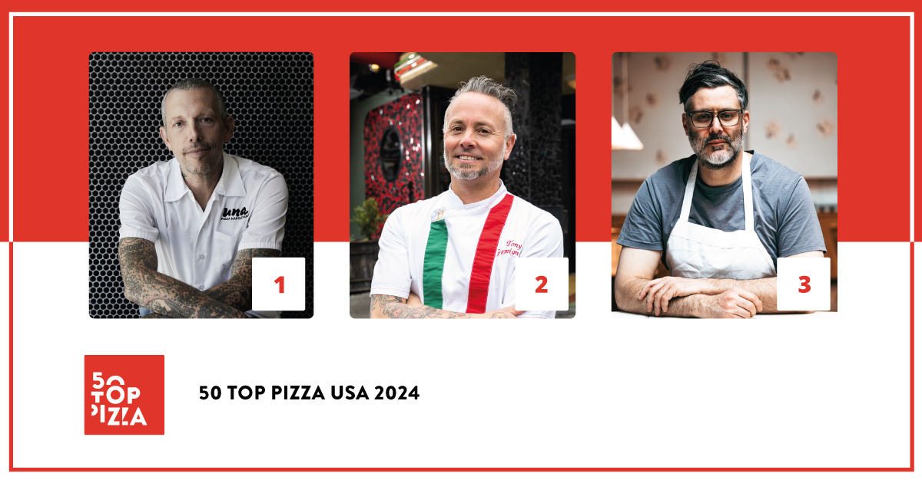

50 TOP PIZZA USA 2024:
"UNA PIZZA NAPOLETANA" IN NEW YORK HAS BEEN RECONFIRMED
THE BEST PIZZERIA IN THE UNITED STATES

Second place "Tony’s Pizza Napoletana" in San Francisco and third "Pizzeria Beddia" in Philadelphia.

The best Pizza Slice is from "L'industrie Pizzeria" in New York

New York City asserts its dominance in the U.S. pizza scene, with 17 restaurants in the guide, followed by Chicago (7), and Portland (6). The most represented state is New York.

New York, June 26th, 2024 – Una Pizza Napoletana, in New York, is reaffirmed as the best pizzeria in the United States, according to the influential 50 Top Pizza guide. The announcement was made yesterday at 6 PM at West Edge, within Chelsea Market, during a highly attended ceremony hosted by Scott Wiener and broadcast live on the network's social media channels.

This is an important confirmation for Anthony Mangieri, Una Pizza Napoletana's owner, who was visibly moved during the ceremony for reaching for the third time in a row the top of the United States list. In second place is Tony's Pizza Napoletana in San Francisco, by Tony Gemignani. The third spot on the podium goes to Pizzeria Beddia in Philadelphia, by Joe Beddia.

In fourth place is Ribalta, in New York; in fifth place is Ken’s Artisan Pizza, in Portland, and sixth is Jay's, in Kenmore. Another New York restaurant, Don Antonio, takes seventh place. Eighth is Pizzeria Sei, in Los Angeles; ninth is La Leggenda in Miami, and tenth is Robert's in Chicago.

The big novelty of 2024 is 50 Top Pizza Slice USA 2024, featuring the top ten pizza slices in America. The first place goes to L'industrie Pizzeria, in New York; second to Slice & Pie, in Washington, and third to Taglio, in Mineola.

The eagerly awaited special awards for 2024 were also presented: the Pizza Maker of the Year 2024 – Ferrarelle Award went to Giorgia Caporuscio of Don Antonio, in New York; the Pizza of the Year 2024 – Latteria Sorrentina Award has gone to Mission Impossibile of Tony’s Pizza Napoletana in San Francisco, a completely vegetarian pizza; the New Entry of the Year 2024 – Solania Award has gone to Pizzeria Beddia, in Philadelphia; the Performance of the Year 2024 – Robo Award went to Robert’s, in Chicago; the Best Fried Food 2024 – Il Fritturista - Oleificio Zucchi Award was given to La Leggenda, in Miami; the Best Pasta Proposal 2024 – Pastificio Di Martino Award was taken home by Partenope Ristorante, in Dallas; the One to Watch 2024 – Orlando Foods Award has gone to GRANA, in Portland; the Best Beer Service 2024 – Peroni Nastro Azzurro Award went to Zeneli in New Haven, and finally the Best Dessert List 2024 – Cremoso - La Dispensa Award has gone to Una Pizza Napoletana, in New York.

The Green Oven 2024 – Goeldlin award which recognizes pizzerias who have environmentally sustainable practices, was awarded to Ken’s Artisan Pizza, in Portland.

New York City confirms its status as the pizza capital of America with 17 restaurants in the guide, followed by Chicago with 7, and Portland with 6. The most represented State is New York with 19 pizzerias, followed by California with 14 pizzerias, and Illinois with 7.

"We have made a significant effort to expand the 50 Top Pizza USA 2024 Guide to include 100 pizzerias," stated the guide's 50 Top Pizza's curators Barbara Guerra, Luciano Pignataro and Albert Sapere "with the top 50 ranked and another 40 where you can enjoy excellent pizza, and the exciting new addition of the Top Ten Best Pizza Slices in the country, which we expect to grow even further in the future. The American pizza movement is in great ferment, with a new generation of artisans increasingly focused on product quality and ingredients, which has gained strong momentum in the past year, including the introduction of tasting menus by many pizzerias."

The top 12 positions in the 50 Top Pizza USA 2024 ranking and the top three positions in the 50 Top Pizza Slice USA 2024 ranking automatically enter into the 100 Best Pizzerias in the World, which will be held at Teatro Mercadante in Naples on September 10th for 50 Top Pizza World 2024.

The next event is scheduled for July 10th at Teatro Manzoni in Milan, where the best pizzerias in Italy for 2024 will be announced.

Project Partners:

Pastificio Di Martino, Ferrarelle, Latteria Sorrentina, Oleificio Zucchi, Solania, Robo 1938, Peroni Nastro Azzurro, Cremoso - La Dispensa, Goeldlin, Fedegroup, Orlando Foods.

The following is the Complete Ranking for 50 Top Pizza USA 2024
1 Una Pizza Napoletana - New York, USA
2 Tony's Pizza Napoletana - San Francisco, USA
3 Pizzeria Beddia – Philadelphia, USA
4 Ribalta - New York, USA
5 Ken’s Artisan Pizza – Portland, USA
6 Jay's – Kenmore, USA
7 Don Antonio - New York, USA
8 Pizzeria Sei - Los Angeles, USA
9 La Leggenda – Miami, USA
10 Robert's – Chicago, USA
11 'O Munaciello – Miami, USA
12 Partenope Ristorante – Dallas, USA
13 Razza Pizza Artigianale - Jersey City, USA
14 Pasquale's - South Kingstown, USA
15 Song' E Napule - New York, USA
16 Kesté - New York, USA
17 Ops - New York, USA
18 Fabrica Pizza – Tampa, USA
19 Pizza Secret - New York, USA
20 Flour House - San Luis Obispo, USA
21 Mission Pizza Napoletana - Winston-Salem, USA
22 Inferno Pizzeria Napoletana – Darnestown, USA
23 Spacca Napoli Pizzeria – Chicago, USA
24 Il Forno - San Antonio, USA
25 Coals Artisan Pizza – Louisville, USA
26 Nardò - Huntington Beach, USA
27 GRANA – Portland, USA
28 Pizza Rock - Las Vegas, USA
29 Bricco Coal Fired Pizza - Haddon Township, USA
30 Nostrana – Portland, USA
31 Valentina’s – Madison, USA
32 Craft 64 – Scottsdale, USA
33 Spark Pizza – Redmond, USA
34 Salsa - New York, USA
35 Antico Pizza Napoletana – Atlanta, USA
36 Tribute Pizza - San Diego, USA
37 Zeneli - New Haven, USA
38 Pizza Delicious - New Orleans, USA
39 Pasquale Jones - New York, USA
40 Pomo – Scottsdale, USA
41 Posto – Somerville, USA
42 Truly Pizza - Dana Point, USA
43 Pizza Baby – Charlotte, USA
44 Pizzeria Florian - East Aurora, USA
45 DØUBLE ZERØ PIE & PUB - Las Vegas, USA
46 Penelope Pizza – Tucson, USA
47 Coda di Volpe – Chicago, USA
48 Si Cara - Cambridge, USA
49 Marco's Coal Fired – Denver, USA
50 San Matteo - New York, USA
50 Angeli’s Pizzeria – Baltimore, USA

The following is the Complete Ranking for 50 Top Pizza Slice USA 2024
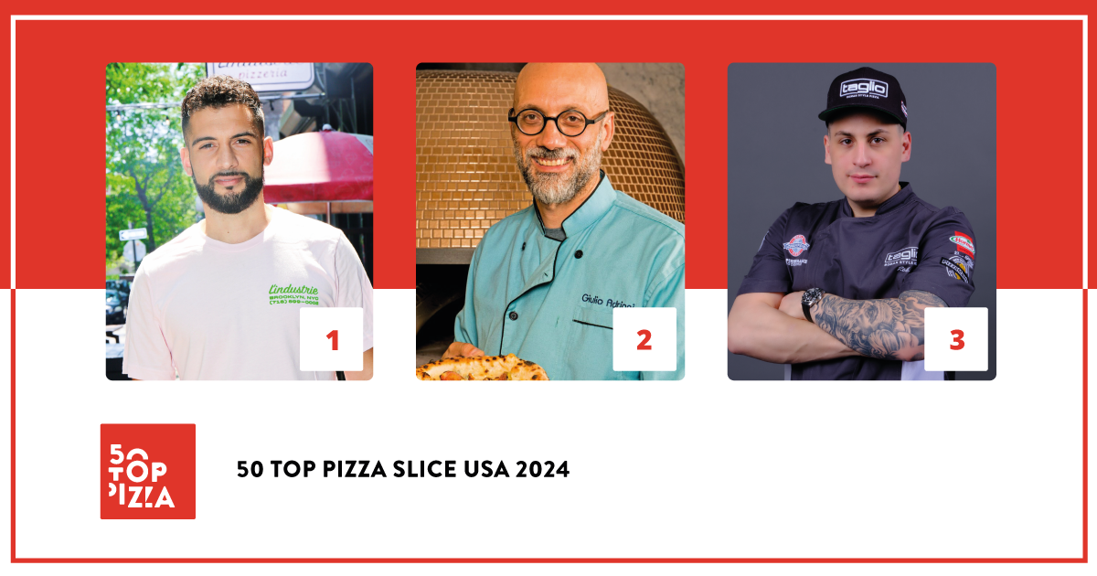
1 L'industrie Pizzeria - New York, USA
2 Slice & Pie – Washington, USA
3 Taglio – Mineola, USA
4 Mano’s Pizzeria - New York, USA
5 Miami Slice – Miami, USA
6 Palazzo Di Pizza - Royal Oak, USA
7 Tivoli – Seattle, USA
8 Mama’s Boy Pizza – Oakland, USA
9 Jimmy’s Pizza Cafe – Chicago, USA
10 L&B Spumoni Gardens - New York, USA

50 Top Pizza USA 2024 - Special Awards
• One to Watch 2024 - Orlando Foods Award
GRANA – Portland, USA
• Pizza Maker of the Year 2024 - Ferrarelle Award
Giorgia Caporuscio of Don Antonio - New York, USA
• New Entry of the Year 2024 - Solania Award
Pizzeria Beddia – Philadelphia, USA
• Best Fried Food 2024 - Il Fritturista - Oleificio Zucchi Award
La Leggenda – Miami, USA
• Pizza of the Year 2024 - Latteria Sorrentina Award
Mission Impossible of Tony's Pizza Napoletana – San Francisco, USA
• Performance of the Year 2024 - Robo Award
Robert's – Chicago, USA
• Best Pasta Proposal 2024 - Pastificio Di Martino Award
Partenope Ristorante - Dallas, USA
• Best Dessert List 2024 - Cremoso - La Dispensa Award
Una Pizza Napoletana - New York, USA
• Best Beer Service 2024 - Peroni Nastro Azzurro Award
Zeneli - New Haven, USA

50 Top Pizza USA – Green Oven 2024 - Goeldlin
• Ken’s Artisan Pizza – Portland, USA

50 Top Pizza USA 2024 – Excellent Pizzerias
https://www.50toppizza.it/50-top-pizza-usa-2024-excellent-pizzerias

Upcoming events 50 Top Pizza 2024
• 50 Top Pizza Italia 2024 – July 10th, Milan
• 50 Top Pizza World 2024 – September 10th, Naples
• 50 Top World Artisan Pizza Chains 2024 and World Pizza Summit 2024 – November 26th-27th, London

As with all of the rankings under the 50 Top brand, 50 Top Pizza USA 2024 is the result of an annual labor carried out by our inspectors who collaborate with the project and who have examined an enormous number of pizzerias throughout the country. Inspections are always done anonymously as per guide policy. Criteria for evaluation include the overall attention given to the customer’s wellbeing, beginning of course with the quality of the final product.

